**Problem:**

I have a customer testing power amplifiers who needs the Power Reduction at Sweep End feature of the ZVA. He is using power reduction between sweeps and manual sweep modes to turn power off to his DUT (a high power amplifier) between tests. Unfortunately we discovered that, under certain conditions, recalling a set file causes output power to turn on regardless of these settings.

This was discovered on firmware version 3.60

**Example:**

To observe this behavior, I used an FSV in zero span (time domain) measurement mode centered at 2.11 GHz (this corresponded to a frequency within the customer’s measurement setup). I set a manual sweep time of 10 seconds in order to be able to see all output power from the ZVA. I connected the FSV input to Port 1 of the ZVA.

I had the ZVA set to a very narrow frequency sweep (2.1 GHz – 2.12 GHz) centered at 2.11 GHz in order for the FSV to observe the output. The ZVA is also set up for manual sweeps and Power Reduction at Sweep End. Most of these settings are captured in the accompanying set file “spikey.zvx”.

With the considerations above, here are the steps to reproduce the issue. They must be strictly followed; this bug only occurs in under certain conditions.

1. Preset the ZVA
2. Make sure Power reduction at sweep end is enabled.  
   System Config (hard key) -> System Config (soft key) -> Power (tab) -> “Power reduction at sweep end” is checked
3. Recall the included set file “spikey.zvx”
4. Manually start a sweep  
   Sweep (hard key) -> Restart (soft key)
5. 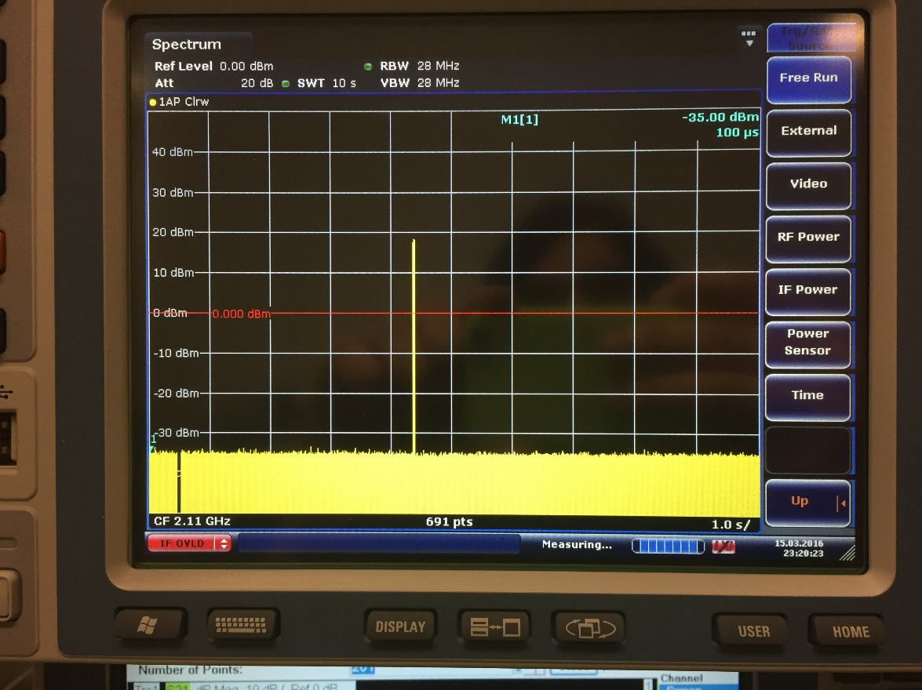Observe power output on the FSV. It should look something like this:

Sweep Triggered

1. Make some changes to the setup in order to force the ZVA to allow you to recall the set file  
   (e.g. change the start frequency to 2 GHz)
2. Recall the set file “spikey.zvx”  
   Recall (hard key) -> Choose spikey.zvx, click Open
3. 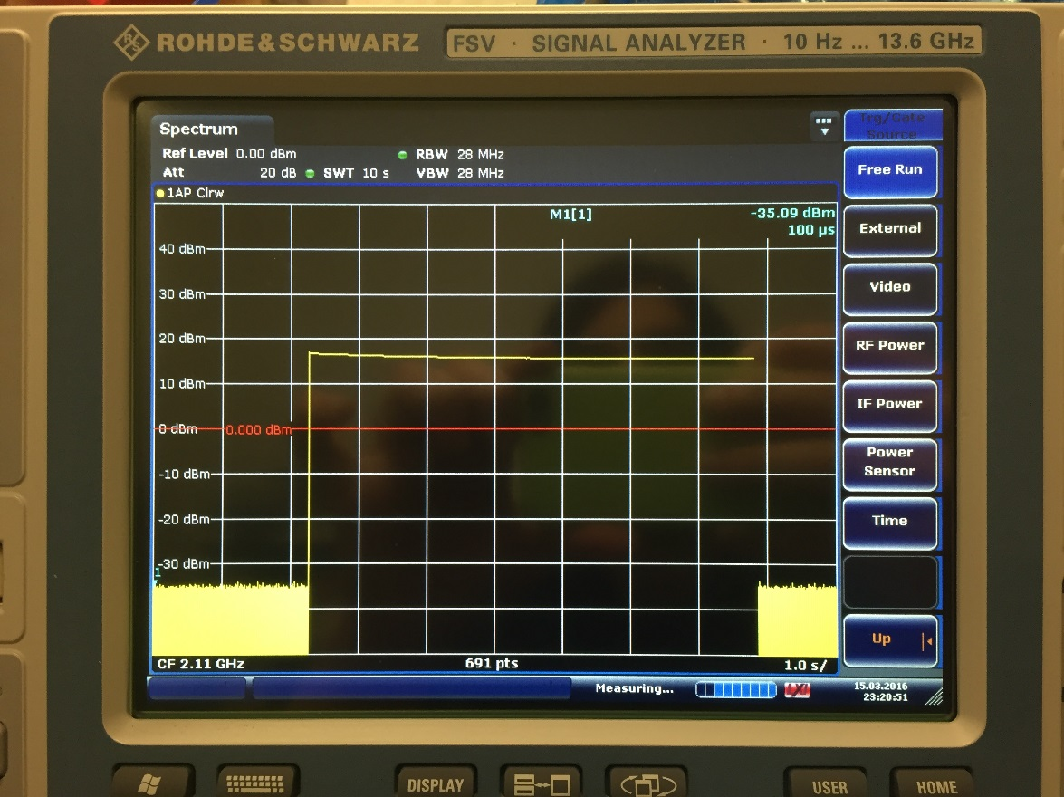Observe the output power on the FSV. It will now constantly be 20 dBm, despite the channel being in manual sweep mode and the Power reduction at sweep end being set.

Set File Recalled

1. Start a manual sweep  
   Sweep (hard key) -> Restart (soft key)
2. 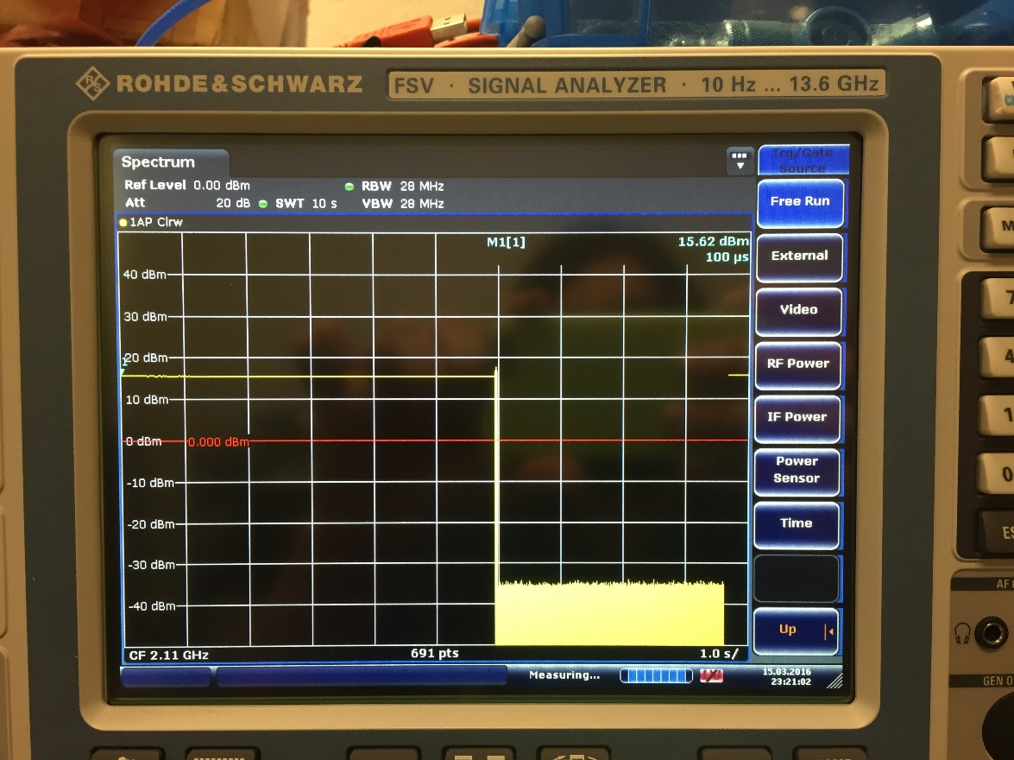Observe the power output on the FSV. It will turn off after the sweep.

Sweep, Power Reduced